Design sketch
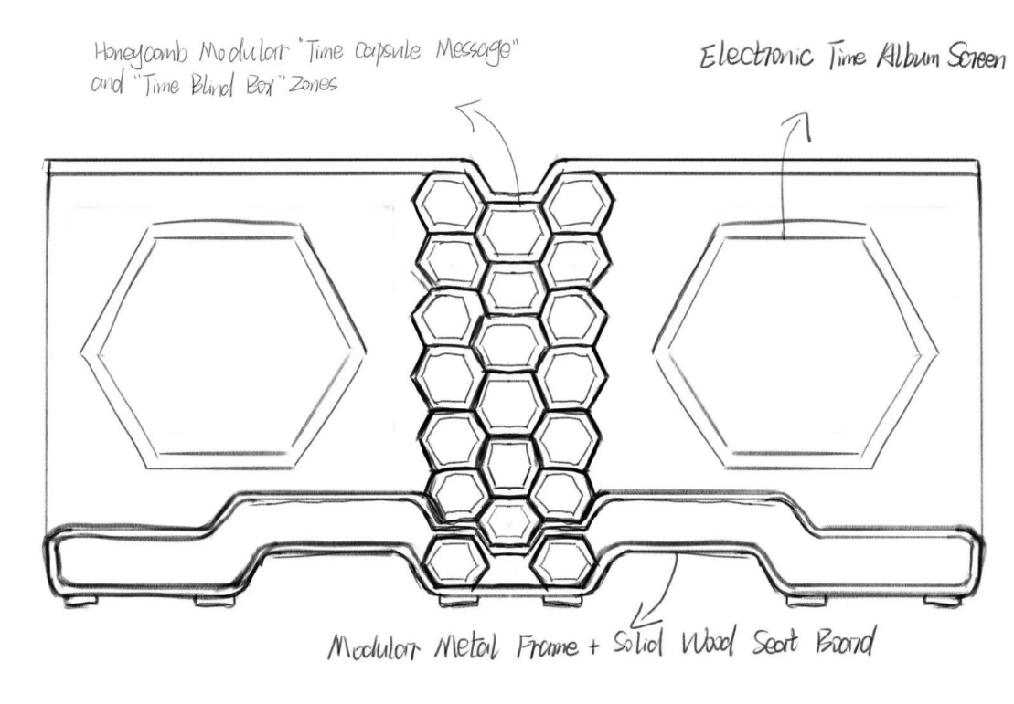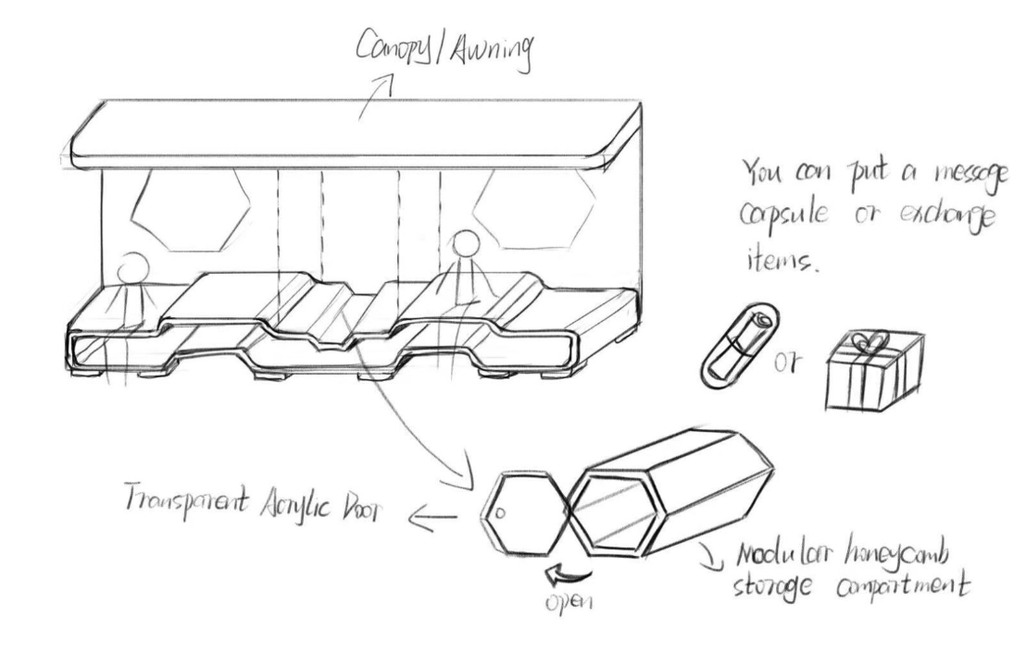

Model Display
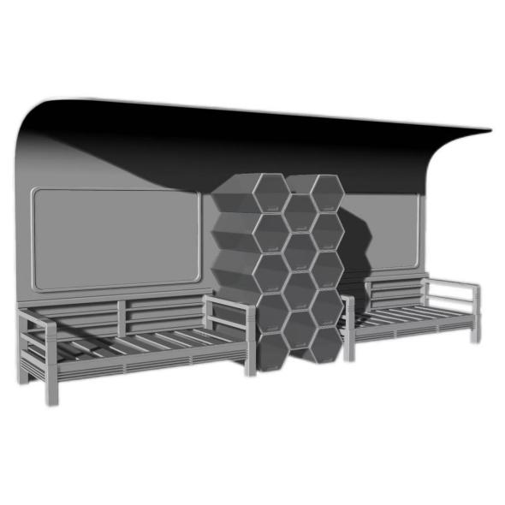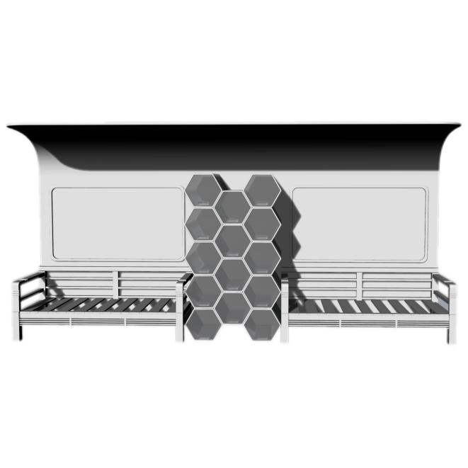
Rendering
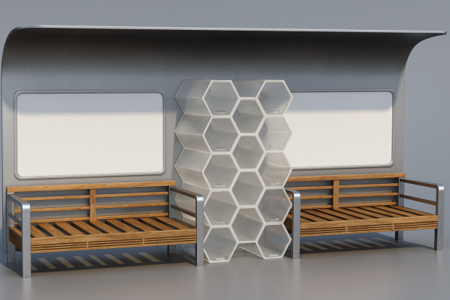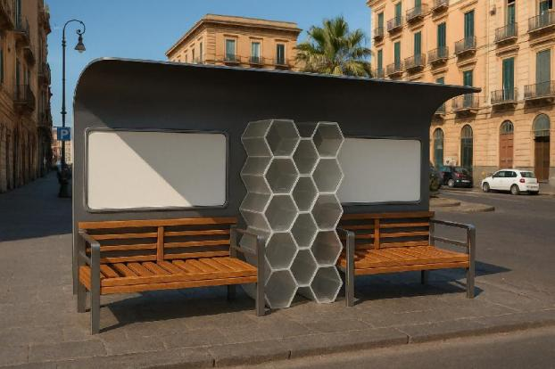
Product Description
1.1Adaptive Design of the Main Bench
The bench adopts a structure of “modular metal frame + solid wood seat board” to ensure stability and comfort. Key parameters are tailored to the elderly:
Seat height: 45cm (aligning with the elderly’s habit of exerting force when standing up);
Seat depth: 50cm;
Seat width: 60cm per person (accommodating 3-4 people in total);
The seat surface is treated with anti-slip textures.
The backrest is 75cm high, with an added curved lumbar support (the curve fits the elderly’s waist contour). The armrests are 10cm wide and 25cm high, facilitating the elderly to hold and stand up. A 15cm gap is reserved at the bottom of the bench for placing canes or wheelchair footrests.
2.2 Detailed Optimization of Functional Areas
Time Message Area
A time capsule message box is placed next to the bench, with paper and pens provided. Elderly tourists and local elderly residents are invited to write down “their current feelings” or “a message to each other”—these messages can be exchanged for reading. After writing and putting a message into a capsule, one capsule can be taken out. Staff organize the messages once a month, scan them, and compile them into a “Bench Time Album”.
Blind Box Exchange Area
A transparent acrylic blind box cabinet is set up, with 20 internal compartments. Local elderly residents place small items (such as old stamps, handcrafted accessories) with story cards inside, while visiting elderly tourists can exchange these items with their own small gifts (such as hometown postcards, bookmarks), establishing emotional connections through objects.
Story cards: Uniformly designed, marking the origin of the item and the contact information of the elderly resident who provided it;
Paper and pens are prepared for elderly tourists to write down exchange remarks;
Graphic exchange rules are posted on the side of the blind box cabinet, along with schematic diagrams of steps for “placing items into the cabinet” and “redeeming gifts”.
2.3 Auxiliary Lightweight Digital Tools
To balance digital experience and operational simplicity, “voice message boxes” and “large-font electronic time albums” are introduced:

Voice message boxes: Placed next to the message boxes, marked with “Don’t want to write? Speak your mind”. The elderly can press the red recording button to record a voice message within 1 minute. The system automatically marks the date, and staff transcribe the voice into text monthly and input it into the “Time Album”;
Large-font electronic time albums: A 15-inch touchscreen is installed next to the bench, with adjustable brightness. It supports “page turning”, “zooming in”, and “reading aloud” functions. The elderly can click to view messages and blind box stories over the years, or ask staff for assistance with operation.

